Hi

When you get the 736R to HRD translator board you will need to install it. This is very simple. Windows already has the driver in it.

1. Windows should recognize the 736R to HRD translator as “CDC RS232 Emulation Demo”.
Windows will now prompt the user for driver information.
2. In the “Welcome to the Found New Hardware Wizard” window, select “No, not
this time” and then Next.

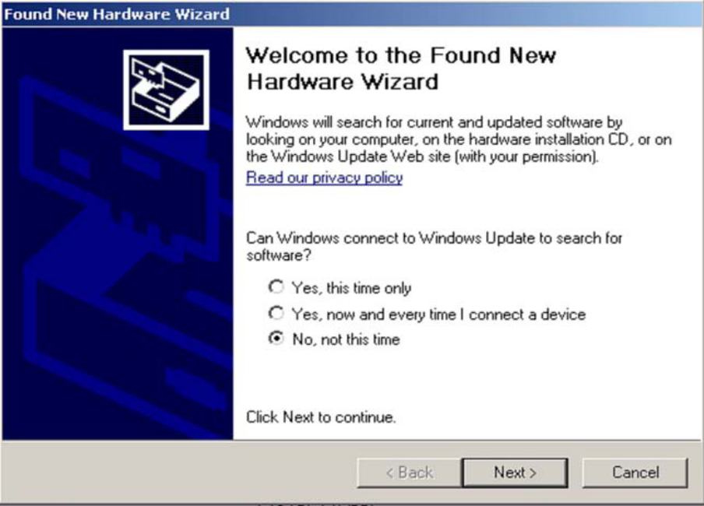

- The wizard will then prompt the user for a location from which to load the software for the communication port. Select ”Install from a list or specific location (Advanced)” and click Next.

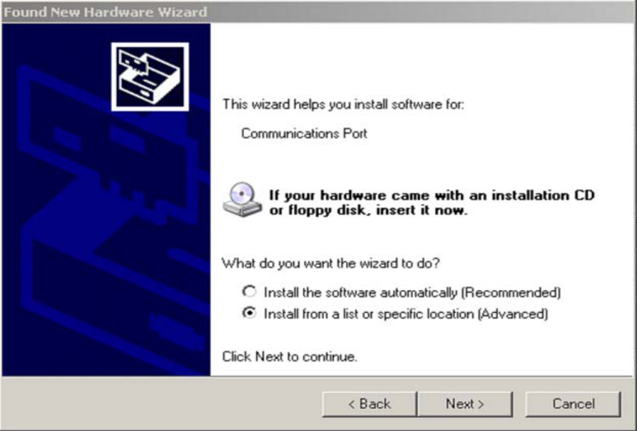
The wizard now prompts the user for the location of the .inf file that Windows will use
to automatically configure the binary driver files (.sys files) to create the Virtual COM
Port connection for the USB. Ensure that both “Search for the best driver in these locations”
and “Include this location in the search” are both selected. Select Browse and
navigate to the mchpcdc.inf which is attached in the email.

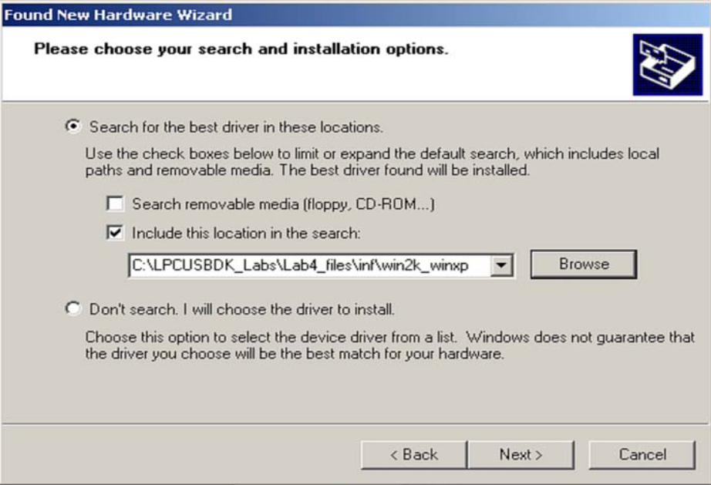
The window should now begin loading the software. If any warnings are issued, select
Continue Anyway.
4. The wizard should indicate that the software for the Communications port was
successfully installed. Select Finish.

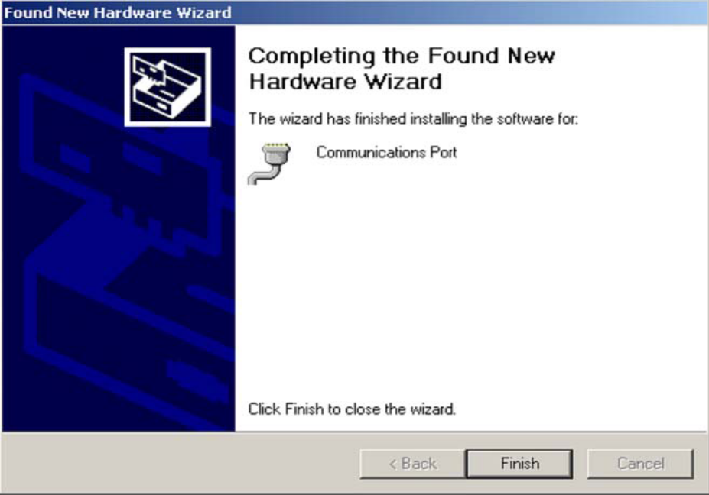

Using with Ham Radio Deluxe

Once you have the board recognized as a USB device you can connect to HRD. On the Connect pop-up of HRD you need to first click on the “Serial ports” tab to see which comport your device has been assigned. It won't be comport 1. Comport 1 is the standard serial port, usually, except on laptops without a serial port.
HRD is not very good at this. So if you cannot figure out which port it is then you will have to go to the Device Manager. Control panel → System → Hardware tab → Device Manager button → expand Ports (Com & LPT). Click on the different ports and find the one which says “Location 0 (CDC RS-232 Emulation Demo)”.
Remember the port number. Then make your new connection the same as the highlighted one below. Make sure you use your own port number though. Your picking the FT-847 as your radio remember.

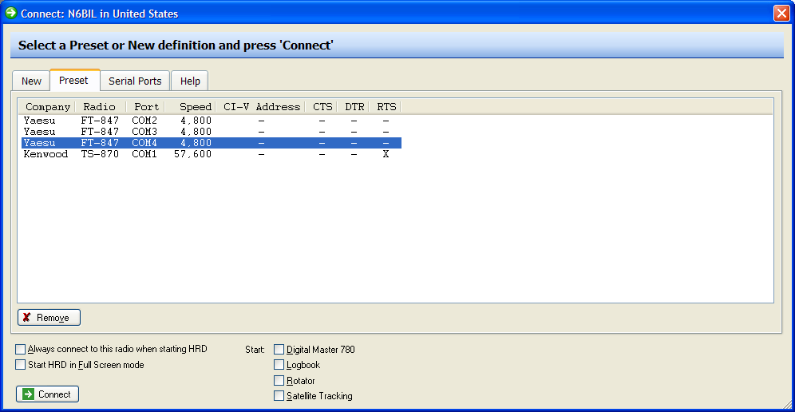

Known issues with the 736R to HRD Board

1. The original test board would on certain computers not be recognized as a USB device. This turned out to be what I believe is a power issue. When a USB powered port hub was installed on these computers the test board worked. Also when the custom printed circuit board came back and was used these issues went away even on the computers that failed before. The custom board is lower power than the test board. Problem believed solved.

2. When HRD is running and connected to the 736R, if you press the SAT button the 736R will go into SAT mode. If you look on the HRD screen you will see that the SAT button is lighted. Lighted means that the lettering appears brighter. If you now press the TX button on HRD the SAT button will now appear unlighted. This of course should not happen. This is a known bug in HRD not in the interface. If you go into the Satellite module of HRD and press help, and then scroll slightly more than halfway down the help screen to the FT-847 section you will see this problem noted by HRD. The solution is as noted by HRD to use the radio mike button or MOX button to key transmit.

- Band changing. This one took sometime to figure out and Dave Dowler KA6BFB helped a lot. Band changing is when you want to change, for example, the receive frequency to the 70 cm band from the 2 meter band, and likewise, the transmit frequency from the 70 cm band to the 2 meter band. If you look at the manual for the commercial program SATPC32, it says you cannot do this. SATPC32 says to disconnect from HRD and flip the SAT switch on the front of the radio to change bands. That is V/U to U/V or vice versa. This maybe true in a 736R with only two bands, but is not true in 736R's with 3 or more bands. I need someone who has a 2 band radio to test this. The problem is simple and once you understand, it is easy to change bands while connected. The thing to understand is that the 736R cannot be in the same band on both transmit and receive. Therefore to change bands you must change one of the two frequencies to a band that is unused. On my radio I have a third band. It is 6 meters. So I can temporarily park one of the two frequencies there and change the other. Then change the parked band frequency to the correct one. I hope this may be possible on a two band radio also. The trick in that case would be to put one of the two frequencies out of band on 6 meters for example, then follow the above instructions. Hopefully someone with a two band radio can test this.

73's
Chuck
chuck.zdz80@gmail.com
n6bil

